USB麦克风使用说明书
(请务必在使用前仔细阅读本手册)
- 产品简介
本产品是专门针对台式电脑、笔记本电脑等网络语音娱乐用途而设计的最新一代数码音频产品，在网络唱歌、语音聊天、网络主持、网络喊麦、个人录音、音乐聆听等应用中均有非常出色的效果体现。
此麦克风为全免驱设计，即插即用，包括WINDOWS、LINUX等常见操作系统上均可正常使用。
- 产品使用
麦克风示意图：
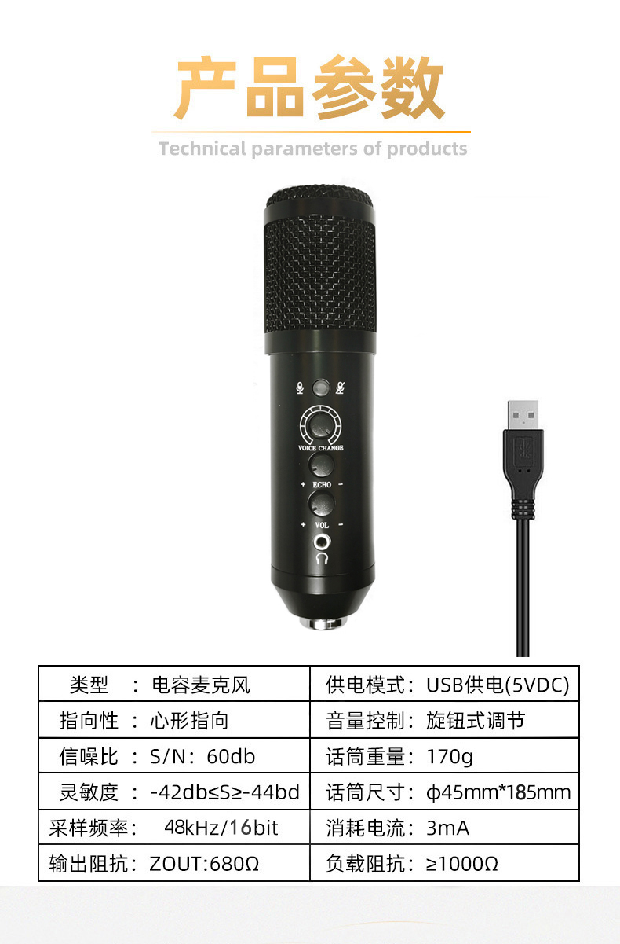
如上图所示，拥有如下接口：
一个耳机接口，用于插入耳机。
一个话筒音量，用于控制话筒音量播放。
一个麦克风混音音量，用于控制话筒混音播放。
一个变音，用于控制男变女、女变男、娃娃音。
一个录音静音开关
- 用于控制麦克风录音与静音；
- 一上机麦克风默认降噪打开，长按5秒，麦克风降噪关闭。
一个USB插口，用于接电脑USB接口。
USB麦克风内部采用精密电子线路控制，具有良好心形指向拾音和高感度输出，噪音低，动态范围宽等特点。
- 电脑设置
- 查看麦克风与电脑联接是否正常
3.如果麦克风接入正常，显示绿色打勾，否则要检查话筒是否接入正常

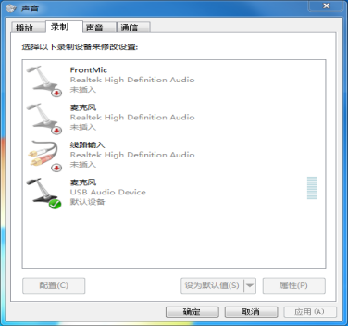
1.右键单击右下角小喇叭（如下图）

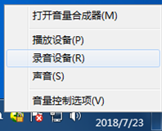
2、打开设置侦听设备选项，把开启外放取消，否则会产生噪音
2.点录音设备
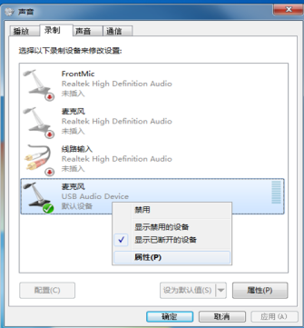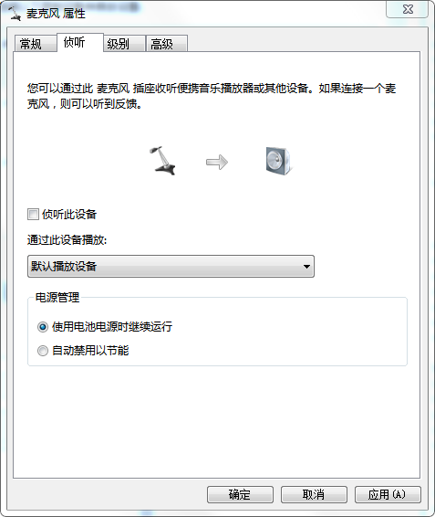
2.把侦听设备不打勾
注：拔了麦克风再插入电脑，如果产生电流声，请打开本界面，把√去掉确定即可
1.点属性

- 设置麦克风音量
一般情况下设置在50至70之间，音量太大会产生底噪

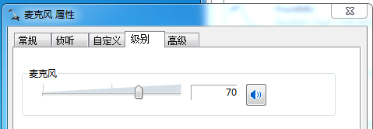

四、重要提示

4、设置播放——扬声器属性:级别越大，音量越大 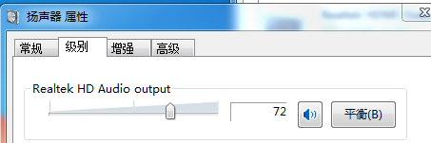

- 重要提示
- 录音开关绿灯亮，即控制麦克风录音，人说话的声音可以进入到电脑；按一下红灯亮，即控制麦克风静音，隔离人说话的声音进入到电脑。一上机麦克风默认降噪打开，长按5秒，麦克风降噪关闭；再长按5秒，麦克风降噪打开。
- 本产品拾音能力强，如使用音箱近距离监听，在唱歌、聊天的时候容易出现啸叫或声音清晰度下降的情况，应尽量不要在使用麦克风时开启音箱近距离监听。本产品接音箱进行放音的时候，必须注意话筒的音量和朝向（不要对准音箱），避免产生啸叫。
- 本产品拥有独立耳机输出接口，支持使用耳塞或耳机作为监听使用。
4.本产品内部配备微电脑控制芯片进行整机功能实现，在受电源冲击等特殊情况下，可能出现非正常工作情况，此时重新检查设备即可。

*本产品相关规格如有变更，恕不另行通知。
USB microphone User Manual
（Please be sure to read the manual carefully before using）
一、Product introduction
This microphone is the latest generation of digital audio product design for Desktop and laptop comput-

ers Network voice entertainment.Give you excellent experience in network singing,voice chat,web hosti-
ng,family karaoke, individual recording,music listenin
g.
This microphone is free drive design,plug and play, microphone can be used on common system includi-
1. Right-click the speaker in the lower right corner

ng WINDOWS,LINUX,etc.
二、Products use

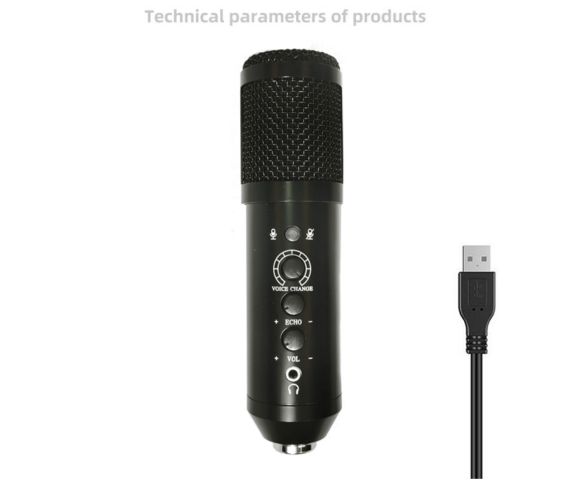
Microphone diagram:
As shown in the above,has the following in terface:
2.Click on the recording device
A headphone jack used to insert the headset.
A stereo music volume knob used for music playing.
A stereo mixing volume knob used to control the mixing.
A variable tone potentiometer for the control of male to female, female to male, doll sound.
A recording mute switch for 1）controlling computer recording and mute；2) Long press for 5 seconds, and the microphone noise reduction is off.
A USB port, used to connect computer USB interface.
Technical parameters
Sound head: 16mm capacitor
Frequency response: 30Hz-20KHz
Directivity: heart-shaped pointing
Sensitivity:(－42dB±2dB)
Power supply: USB DC5V power supply
三、Computer Settings
（1）Check the microphone is connected to the computer properly
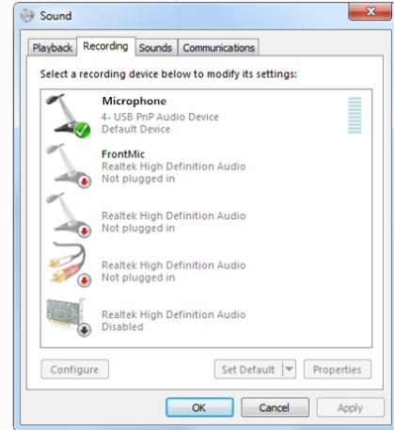

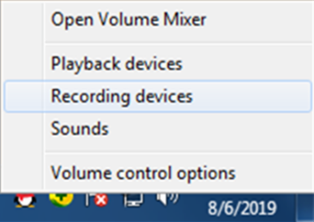
If the microphone is connected normally, display a green tick.
（2）Set the listening device , open the external playback to hear your own voice
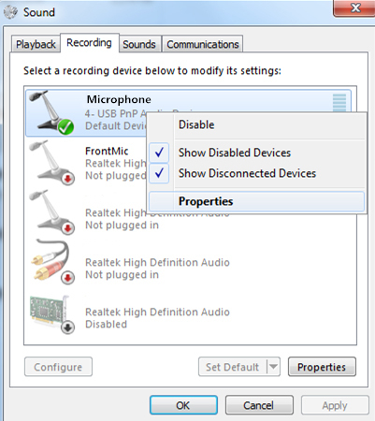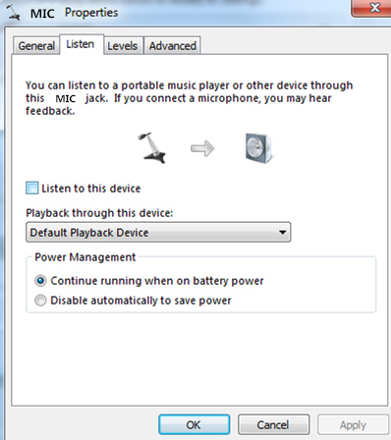
Note: unplug the microphone and then insert it into the computer. If the current sound is generated, please open this interface and remove the square root
2. Uncheck the listening device
1. Some properties
（3）Set the microphone volume
Generally set between 50 and 70, The volume is too high to generate bottom noise
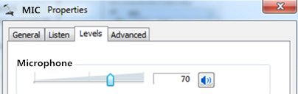

(4)Set playback -- speaker property
The higher the level, the louder the volume
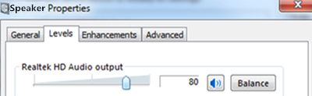
三、Important notice
1.The green light of recording switch is on, that is, the computer recording is controlled, and the voice of people speaking can enter the computer; Press the red light, that is to control the computer mute, isolation of the voice into the computer.
2.This microphone pickup ability is very strong,if you use the speakers for close-range Monitoring,
microph-one will howling or sound clarity decre-
ases when singing,chatting.Please don’t use the speakers for close-rang monitoring when using the microphone. When microphone connect the speaker,must pay attention to the volume and direction(do not aim at speaks)of microphone,
avoid to howling.
3.This microphone has an independent headph-
one output interface,support the earplugs or hea-
dphone for monitoring.

*The related specification or deployment are subject to change without any prior notification.

