Simple Chinese description of uSDR

USDR is derived from uSDX, from QCX-SSB, the early QCX. An open source SDR machine.
Software website:https://github.com/threeme3/QCX-SSB/tree/feature-rx-improved
There will be updates at any time, if you are interested, you can pay attention!

Most of the kits provided by this team have been installed, but it is recommended to refer to the original website for relevant operations. The parts improved by this team are compatible with the original open source parts. For the definition of the socket opening, please refer to the following graphic description.

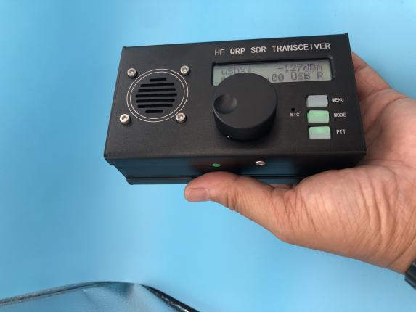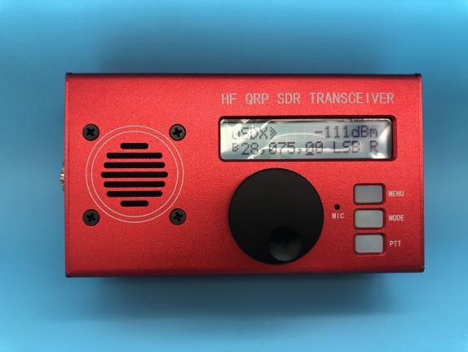

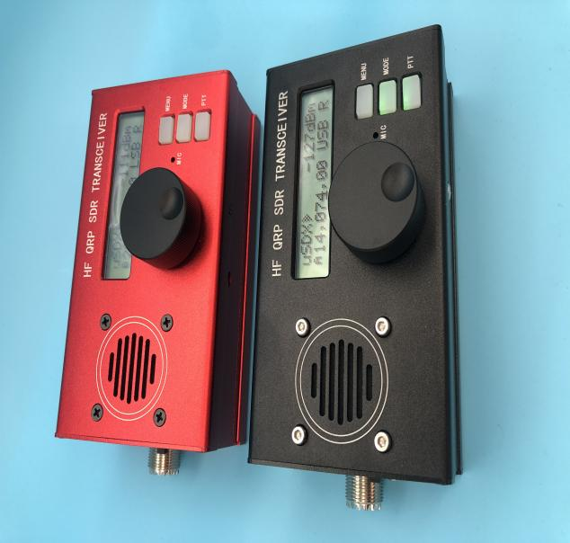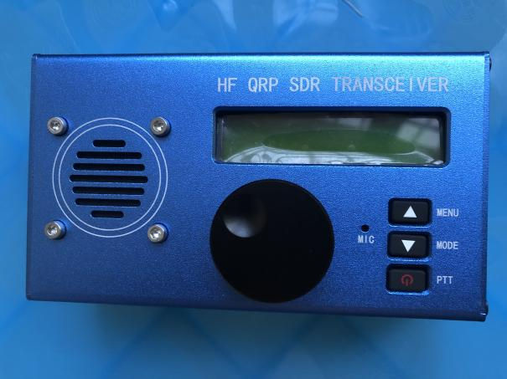

Description of the circuit principle of uSDR:
This is a simple experimental modification to convert the QCX to a (Class E driven) SSB transceiver. It can be used to establish a QRP SSB contact or (in combination with a PC) for digital modes such as FT8, JS8, FT4. It can be fully continuously tuned across the 80m-10m band in LSB/USB mode with 2400Hz bandwidth, has up to 5 W PEP SSB output (we modified it to 10 W Max at 13.8 V external), and has a full software-based break-in VOX.Fast RX/TX switching in voice and audio. Digital operation.

The SSB transmit stage is implemented entirely in a digital and software-based manner: the core of the ATMEGA328P is to sample the input audio and reconstruct the SSB signal by controlling the SI5351 PLL phase (by a slight frequency change over 800kbit/s I2C). And control that power of the pow amplifier (via PWM on the key shaping circuit). In this way, an E-class driven SSB signal with high power efficiency can be realized.The PWM-driven E-class design keeps SSB transceivers simple, slim, cool, power-efficient, and low-cost (i.e., there is no need for a power-efficient, complex linear amplifier with a bulky heat sink, as is common in SSB transceivers).

For the receiver, most of the original QCX circuitry has been removed and implemented digitally (software): the ATMEGA328P is now implementing a 90-degree phase shift circuit, a (CW/SSB) filter circuit and an audio amplifier circuit (now a class-D amplifier). This greatly simplifies the QCX circuit (50% less components are required) and has many advantages and features:The calibration procedure is no longer required. There are now adjustable IF DSP filters for CW and SSB; There is an AGC and a DSP signal conditioning function for noise reduction, and there are three independent built-in attenuators on the analog front end to help utilize the full dynamic range. The speaker is directly connected and driven by ATMEGA.

The experiment was created to try to implement functionality with minimal hardware while shifting complexity to software. The approach taken here is to simplify the design where possible while maintaining reasonable performance. The result is a cheap, easy to build universal QRP SSB transceiver that is actually very suitable for making QSOs (even in competition situations), but due to the experimental nature,Some parts are still under development and are therefore limited. Feel free to try or experiment with this sketch, let me know what you think or contribute here: HTTPS://github. Com/threeme3/qcx-ssb The original forum discussion on this topic was: QRPLabs Forum.

List of main functions of uSDR:
- With embedded DSP and SDR capabilitiesSimple, fun and versatileQRP SSB HF transceiver;
- EER Class EDriven SSB transmit state
- Approx. 10 W PEP SSB output from 13.8 V supply
- Full mode support: USB, LSB, CW, AM, FM
- DSP filter: 4000, 2500, 1700, 500, 200, 100, 50 Hz passband
- DSP functions: Automatic Gain Control (AGC), Noise Reduction (NR), Voice Triggered Xmit (VOX), RX Attenuator (ATT), TX Noise Gate, TX Driver Control, Volume Control, Signal meter/S-meter in dBm.
- SSB reverse sideband/carrier suppression Transmit: better than -45dBc, IMD3 (two tones) -33dBc, Receive: better than -50dBc
- Multi-band support in the 160m-10m band (and from 20kHz. 99 MHz with performance penalty).
- Open source firmware, built using the Arduino IDE; Experiment allowed, new features can be added, contributions can be shared via Github, software complexity: 2000 lines of code
- Software-based VOX can be used as a fast full intrusion (QSK and half QSK operation) or to assist in RX/TX switching for digital mode operation (no CAT or PTT interface required) with external PTT output for TX/PA control-delay
- Installation of simple modifications with 8 component variations and 8 wires
- Lightweight, low-cost transceiver design: high power efficiency (no need for bulky heat sinks) and simple design (no need for complex balanced linear power amplifiers) due to EER transmitter Class E
- Completely digital and software-based SSB transmit stage: The microphone input is sampled and the SSB signal is reconstructed by controlling the phase of the SI5351 PLL (via I2C tiny frequency variations over 800kbit/s) and the amplitude of the PA (via PWM of PWM). PA key shaping circuit)
- Fully digital-based and software-based SDR receiver stage (optional): The I/Q (complex) signal from the quadrature sampling detector digital mixer is sampled and 90 degrees phase shifted (Hilbert transformed) in software and a pass-added sideband is removed.
- Three independent switchable analog front-end receiver attenuators (0 dB, -13 dB, -20 dB, -33 dB,-53 dB,-60 dB and-73 dB)
- – 135 dBm receiver noise floor at 28MHz (200Hz BW)
- Receiver front-end selectivity: Steep -45dB/decade roll-off +/-2kHz tuning frequency
- Blocking dynamic range: 123dB at 20kHz offset, 78dB at 2kHz offset
- CW decoder, single key/Iambic-a/B keyer. Dots and dashes can be swapped in the menu.
- VFO A/B + RIT and Split with corresponding relay band filter switching via I2C
- CAT support (Jianwu TS480 subset control command), which can stream audio, keys and display text through CAT.
- You may find that this is probably the most cost effective and easy to build standalone SDR/SSB transceiver. The original QCX circuit is greatly simplified (i.e., 50% fewer mounting components, no complex transformer windings, no alignment procedures) and is more versatile to use.

Revision record of uSDR software:
Version No. | Date | Characteristic
[R1.02r] | 2021-04-05 | TX quality improvements, better robustness against RFI feedback, fixed VOX issues, single encoder/button only control option, 16 MHz Arduino Uno/Nano support, CW messaging.
R1.02n | 2021-02-22 | Key reduction, TX bandwidth control, OLED repair, CAT remote control features (including RX audio streaming).
R1.02m | 2021-01-27 | CW Support, TS480 CAT Support, RX Quality Improvement, Half QSK, PA PTT Output with TX Delay, VFO-a/B/RIT, LPF Switching, Backlight Saving, 160m.
R1.02j | 2020-10-10 | Integrated SDR Receiver, CW Decoder, DSP Filter, AGC, NR, ATT, Experimental Mode CW, AM, FM, Quick Menu, Continuous Setup, Improved SSB TX Quality. Fixed LCD, selectable CW spacing.
R1.01d | 2019-05-05 | Q6 is now digitally switched (C31 removed)-improved stability and IMD. Improved signal processing, audio quality, increased bandwidth, cosmetic changes and reduced RF feedback, reduced S-meter RFI, S-meter readings and self-test at startup. Receiver I/Q calibration, (experimental) amplitude predistortion and calibration. (The original QCX-SSB mod is described herR1.01d）
R1.00 | 2019-01-29 | Initial version of the SSB transceiver prototype.

Schematic:
Below the applied schematic, unused components are retained and changed components are marked in red (click to enlarge and download) (link toOriginal schematic）：

Operation
Currently, the following functions are assigned to shortcut buttons (L = left, E = encoder, R = right) and menu items:
Menu item | Function | Button
1.1 Volume | Audio Level (0. 16) and power off/on (turn left) | E + rotation
1.2 Mode | Modulation (LSB, USB, CW, AM, FM) | R
1.3 Filter Bandwidth | Audio Passband (Full, 300.. 3000、300.. 2400、300.. 1800, 500, 200, 100, 50 Hz), which also controls the SSB TX BW. | R Double click
1.4 Tape | Band switch to predefined CW/FT8 frequencies (80, 60, 40, 30, 20, 17, 15, 12, 10, 6m) | E Double click
1.5 Adjustment rate | Adjustment step 10M, 1M, 0.5M, 100 K, 10 K, 1 K, 0.5k, 100, 10, 1 | E or E long press
1.6 VFO mode | Select different VFO or RX/TX split VFO (A, B, split) | 2x R length
1.7 RIT | RX in transmit (on, off) | R Long press
1.8 Automatic gain control | Automatic gain control (on, off)
1.9 Noise reduction | Noise reduction rating (0-8), pass and smooth
1.10 ATT | Analog attenuator (0, -13, -20, -33, -40, -53, -60, -73 dB)
1.11 ATT2 | Digital attenuator in CIC stage (0-16) with 6 dB step sizes
1.12 S table | Type of S-Meter (OFF, dBm, S, S-bar)
2.1 CW Decoder | Enable/disable CW decoder (ON, OFF)
2.2 CW Tone | CW filter + sidetone (600,700)
2.3 CW Offset | CW RX Filter Offset Alignment (QCX only)
2.4 Half QSK | On TX, mute RX on CW symbol and word spaces
2.5 Keying speed | CW Keyer Speed in Paris WPM (1. 35)
2.6 Keyer Mode | Keyer type (Iambic -a, -B, straight key)
2.7 Key Exchange | DIH, DAH input (ON, OFF) of exchange keyer
2.8 Exercises | TX disabled for practice purposes (ON, OFF)
3.1 VOX | Voice control X mit (ON, OFF)
3.2 Noise Gate | Audio threshold for SSB TX and VOX (0-255)
3.3 TX driver | Transmit audio gain in 6 dB steps (0-8), 8 = constant amplitude of SSB
3.4 TX Delay | Delay TX to allow PA relay to fully turn on before TX (0-255 ms)
3.5 MOX | Monitor on Xmit (audio remains unchanged during transmission)
4.1 CQ Interval | The idle time in seconds before a new CQ message is given (0-60)
4.2 CQ message | CQ message text, pressing the left button in the menu will start sending | L
4.3 CW Message 2 | CW message text, pressing the left button in the menu will start sending | L
4.4 CW Message 3 | CW message text, pressing the left button in the menu will start sending | L
4.5 CW Messages 4 | CW message text, pressing the left button in the menu will start sending | L
4.6 CW Messages 5 | CW message text, pressing the left button in the menu will start sending | L
4.7 CW Messages 6 | CW message text, pressing the left button in the menu will start sending | L
8.1 PA Deviation Minimum | PA amplitude PWM level (0-255), representing 0% of RF output
8.2 PA Bias Maximum | PA Amplitude PWM level (0-255), representing 100% of RF output
8.3 Reference frequency | Si5351 actual crystal frequency for frequency calibration
8.4 IQ stage | RX I/Q phase offset in degrees (0. 180 degrees)
8.5 IQ Testing/Calibration | CW Filter Alignment (QCX only)
9.1 Sampling rate | For debugging, testing and experimental purposes
9.2 CPU load | For debugging, testing and experimental purposes
9.3 Parameter A | For debugging, testing and experimental purposes
9.4 Parameter B | For debugging, testing and experimental purposes
9.5 Parameter C | For debugging, testing and experimental purposes
10.1 Backlight | Display backlight (on, off)
Power-on | Reset to factory settings | E Long press
MAIN | Tone frequency (20kHz.. 99MHz) | Rotate
MAIN | Quick Menu | L + E rotation
MAIN | Menu input | L
RIT | RIT return | R
Menu | Menu Return | R

Simple Operation Instructions for uSDR:

The frequency can be tuned by a rotary encoder. The step size can be decreased or increased by a short or long press. Double-click to change the frequency band. Short press the MODE button to change the operating mode; Double-clicking the MODE button reduces the bandwidth of the receiver filter and resets the bandwidth each time the mode is changed. Turn the rotary encoder when pressed to change the volume.

There is a menu available that can be accessed with a short press of the menu key. Using the encoder, you can navigate through this menu. When you want to change the menu parameters, pressing the MENU button allows you to change the parameters using the encoder. With the menu key, you can exit the menu at any time. You can quickly access menus and parameters by pressing the MENU button while rotating the encoder.The parameters can be changed immediately by rotating the encoder.

Receive status, AGC is enabled by default. This increases the volume when there is a weak signal and decreases the volume for a strong signal. This is useful for SSB signals, but annoying for CW operations. AGC can be turned off in the menu, which reduces receiver noise but requires more manual volume changes. To further reduce noise,Noise reduction can be enabled using the NR parameter in the menu. To make the best use of the available dynamic range, the input signal can be attenuated by enabling the front-end attenuator with the "ATT" parameter. Especially at frequencies of 3.5-7 MHz, the atmospheric noise level is much higher, so you can improve the receiver performance by adding attenuation (say 13 dB) and still hear the noise floor.To calibrate the transceiver frequency, you can tune to a calibrated signal source (e.g. WWV (on 10 MHz)) and zero-beat the signal by changing the "Ref freq" parameter; Alternatively, you can use a counter to measure the XTal frequency and set the parameters. The selected S-meter (dBm, S, S-bar) can be selected through the S-meter parameter. Selecting an S-bar displays a signal strength bar with each scale representing an S-point (6 dB).(Note: The team modified the frequency reference using a highly stable Japanese KDS crystal.)

For SSB voice operation, connecting a microphone to the 3.5mm Jack, pressing PTT or pressing the onboard "PTT key" will put the transceiver into transmit mode. Using the "TX Drive" parameter, you can set the modulation depth or PA drive, the default setting is 4, increasing it produces more impact (compressing the SSB). Setting it to a value of 8 in the SSB means that the SSB modulation is transmitted at a constant amplitude (possibly reducing the RFI,But at that expense of audio quality). To monitor your own modulation, you can temporarily increase the MOX parameter. Setting the menu item "VOX" to ON puts the voice transceiver into Xmit voice operation (TX mode once audio is detected). The VOX sensitivity can be configured using the "VOX threshold" parameter in the menu. Note 3), using a PWM signal, the optimum operating range can be specified,From just above the MOSFET threshold level to the maximum peak power to use (0-180 is a good value on my QCX).

For FT8 (and any other digital) operation, select one of the pre-programmed FT8 bands by double-clicking the rotary encoder, connect the headphone Jack to the sound card microphone Jack, connect the sound card speaker Jack to the microphone Jack, and then press and hold the MENU button and turn the large knob to enter the 3.1 menu to initiate VOX mode. Turn the volume down to a minimum and then launch your favorite FT8 application (e.g. JTDX).You can set the sensitivity of the VOX in the VOX Threshold parameter.

When the machine is powered on, a self-test is performed. It is checking supply and bias voltages, I2C communication, and algorithm performance. If there is a deviation, the display will report an error during startup. It also discovers the functionality of the transceiver based on the module being made. The following functions are detected and displayed on the display: "QCX" for QCX without Mod; "QCX-SSB" for QCX with SSB mod;"QCX-DSP" of the QCX disconnected and connected to the loudspeaker (via decoupling capacitor) by SIDETONE; "QCX-SDR" for QCX with SDR mod. Please check if this feature matches the mod.

Technical description of uSDR circuit:
Principle of operation: Block diagram of the QCX-SSB, SDR transceiver:
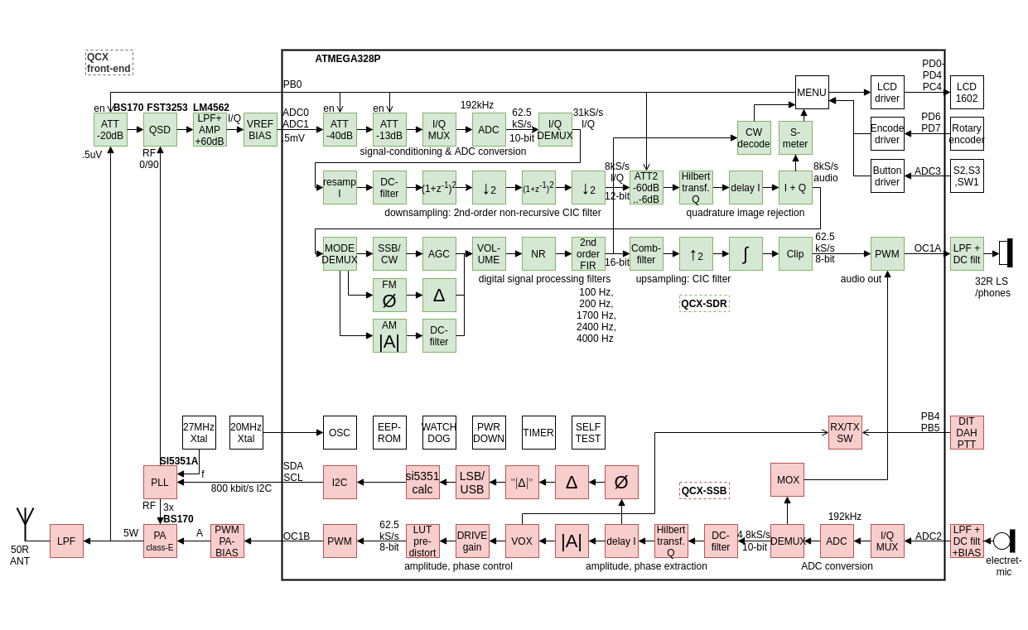
For SSB reception, replace the QCX analog phasing receiver stage with a digital SDR stage. This means changing the phase-shifting operational amplifier IC6 to a conventional amplifier, and feeding separate I and Q outputs directly into the ATMEGA328P ADC input for signal processing. ATMEGA328P oversampling (oversampling) the ADC input at a sampling rate of 62kHz, decimating the high sampling rate to a lower sampling rate, and performing phase shift through Hilbert transform, and summing the results to obtain sideband suppression ; Subsequently, it applied low-pass filtering, AGC and noise reduction functions. Since the original QCX phase shift network and analog CW filter are not used, about half of the original QCX components can be omitted. By integrating the functions of IC7B into IC6A, another operational amplifier can be saved. The ADC input is low-pass filtered (-40dB / ten times roll-off at 1.5kHz cut-off frequency) to prevent aliasing, and the input is biased with a 1.1V analog reference voltage to obtain higher sensitivity and dynamic range . Using a 10-bit ADC and a 4x oversampling rate, a theoretical dynamic range of 72dB can be obtained in a 2.4kHz SSB bandwidth. LSB/USB mode switching is accomplished by changing the 90-degree phase shift of the CLK0/CLK1 signal of the SI5351 PLL. Three embedded attenuators are provided to make the best use of dynamic range. The first attenuator is the RX MOSFET switch Q5 responsible for 20dB attenuation, the second attenuator is the ADC range (1.1V or 5V) selected by ATMEGA ADC analog reference (AREF) logic and is responsible for 13dB attenuation, and the third attenuation The converter is a pull-down of the analog input on ATMEGA, with a GPIO port responsible for 53dB attenuation. The combination of three attenuators can provide attenuation levels of 0dB, -13dB, -20dB, -33dB, -53dB, -60dB, -73dB.

For SSB transmission, the QCX DVM circuit was changed and used as an audio input circuit. Add an electret microphone (with a PTT switch) to the Paddle jack connected to the DVM circuit, where the DOT input serves as the PTT and the DASH input serves as the audio input. The electret microphone is biased at 5V through a 10K resistor. A 10nF blocking capacitor prevents RF leakage into the circuit. The audio is fed into the ADC2 input of the ATMEGA328P microprocessor through a 220nF decoupling capacitor. ADC2 input is biased at 0.55V to 1.1V analog reference voltage through a 10K voltage divider network, with 10-bit ADC resolution, which means that the microphone input sensitivity is about 1mV (1.1V/1024), which is enough to process voice signals.

The new QCX-SSB firmware was uploaded to ATMEGA328P and promoted the development of digital SSB generation technology in a completely software-based manner. The DSP algorithm samples the ADC2 audio input at a rate of 4x4800 samples/sec, performs the Hilbert transform, and determines the phase and amplitude of the complex signal. The phase change is limited to Note 2 and converted to a positive (for USB) or negative (for LSB) phase change, and then into a temporary frequency change, which is sent 4800 times per second to SI5351 at an I2C rate of 800kbit/s per second PLL. This causes the phase change of the SSB carrier signal and provides an SSB signal with a bandwidth of 2400 Hz, thereby attenuating the spurs in the relative sideband components.

The amplitude of the composite signal controls the power supply voltage of the PA, thereby controlling the envelope of the SSB signal. The key shaping circuit is controlled by a 32kHz PWM signal, which can control the PA voltage between 0 and 12V in 256 steps, thereby providing a dynamic range of (log2(256) * 6 =) 48dB in the SSB signal. Remove C31 to ensure that Q6 works as a digital switch, thereby improving efficiency, thermal stability, linearity, dynamic range and response time. Although amplitude information is not mandatory to make the SSB signal understandable, adding amplitude information can improve quality. The complex amplitude can also be used in VOX mode to determine when RX and TX conversion should be performed. Instead of using a key shaping circuit for envelope control, the (filtered) PWM signal can be used to directly bias the PA MOSFET.

IMD performance depends on the quality of the system: the linearity (accuracy) of the amplitude and phase response and the accuracy of these quantities (dynamic range). Especially the bit width of the DSP, the precision used in the DSP algorithm, the PWM and key shaping circuits that provide the phase response of the PA and PA are very important. Reducing (or eliminating) C32 can improve IMD characteristics, but at the expense of increasing the PWM product around the carrier.

Improved result: Actual communication example: I used 5W QCX-SSB to call CQ at 40m and was received by Hack Green websdr about 400 kilometers. Please note that since then, the audio quality has been further improved.

Several OM reports stated that QCX-SSB was successfully modified, and it was able to communicate with SSB QRP DX within a range of thousands of kilometers in the 20m and 40m frequency bands. In the CQ WW competition, I can use CN3A as the farthest contact in just a few hours, using 5W power and a reverse V voltage at 40m to make 34 random QSOs at 34m. I can observe In some cases, the advantage of using SSB with constant envelope is where the signal is weak; for FT8, I used Raspberry Pi 3B+ with JTDX, so that FT8 touches all the way to NA.

Measurement: Use QCX-SSB R1.01, improved RTL-SDR, Spektrum-SVmod-v0.19, Sweex 5.0 USB audio device and Audience player to perform the following performance measurements. It is recognized that this measurement setup has its own limitations. Therefore, since the device can easily enter an overload state, the dynamic range of the measurement is limited to some extent by RTL-SDR. Use the following settings for measurement: USB modulation, no pre-distortion, two-tone input 1000Hz / 1200Hz, where the audio level is set before the compression starts.

Measurement results:

Intermodulation distortion products (two tones; SSB with different envelopes) IMD3, IMD5, IMD7: respectively -33dBc; -36dBc; -39dB
Intermodulation distortion products (two tones; SSB with constant envelope) IMD3, IMD5, IMD7: -16dBc; -16dBc; -19dB respectively
Opposite sideband suppression (two-tone): better than -45dBc
Carrier suppression (two tones): better than -45dBc
Broadband spurious (two tones): better than -45dBc
3dB bandwidth (scanning): 0..2400Hz

Attachment: socket description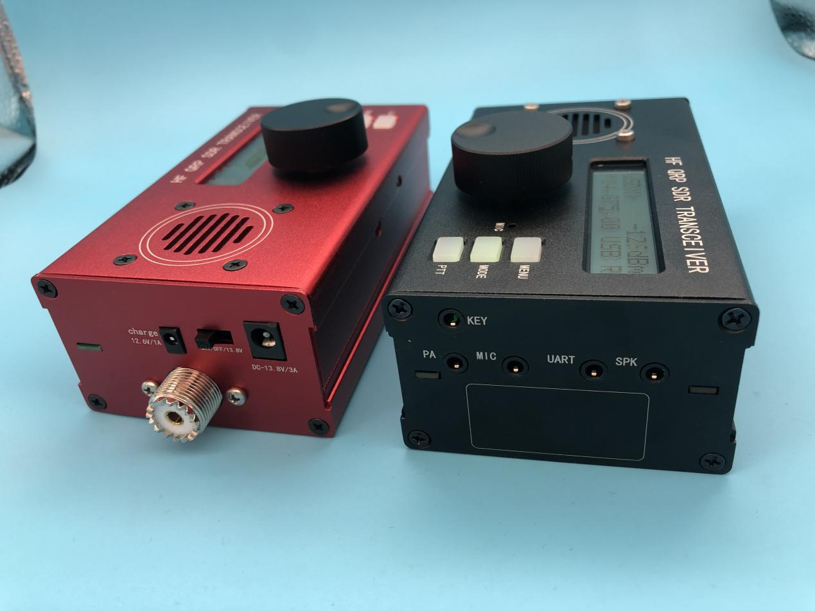

Charge: For the charging port of the built-in lithium battery, you can only use the supplied charger! It is forbidden to use other chargers!
Switch: OFF shutdown BAT: built-in battery power supply 13.8: external power supply
DC13.8V/3A: External power supply port
KEY: automatic key body connection (A, B, single key)
PA: External power amplifier, PTT signal
MIC: External microphone port
UART: Serial communication port (command compatible with TS-480)
SPK: External speaker

Socket definition diagram:
CW interface (you can set the swap point and stroke in the menu):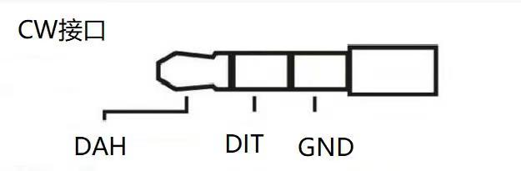
MIC接口：
